1. Install Visual Studio, if you haven’t already, using your Microsoft account supplied by IHCC.
2. Install Micro Focus Visual Cobol (1 yr trial)
   1. Google Micro Focus **Personal Edition**
   2. Click on download your trial version
   3. Select Visual COBOL for Visual Studio Personal Edition
3. 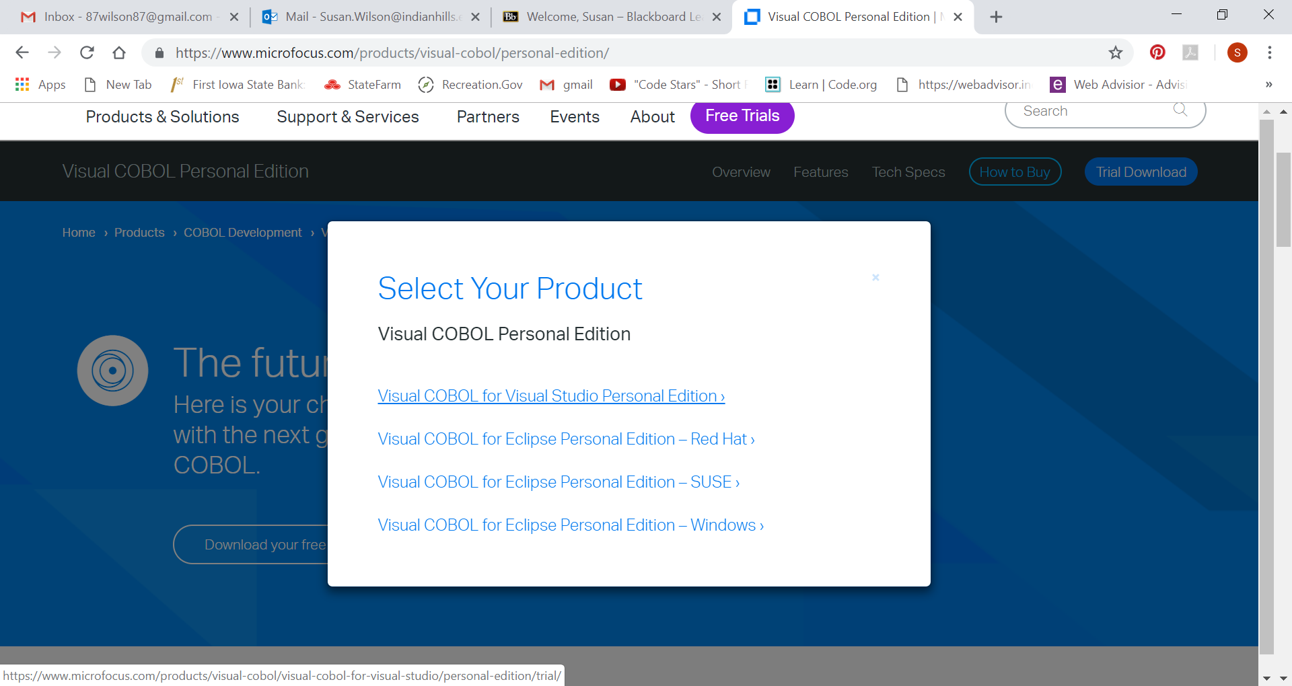
   1. Register by filling out the required contact information and agreeing to their terms. **Use your school email and 641.683.5111 for the phone number.**
   2. Check your email for a registration notice

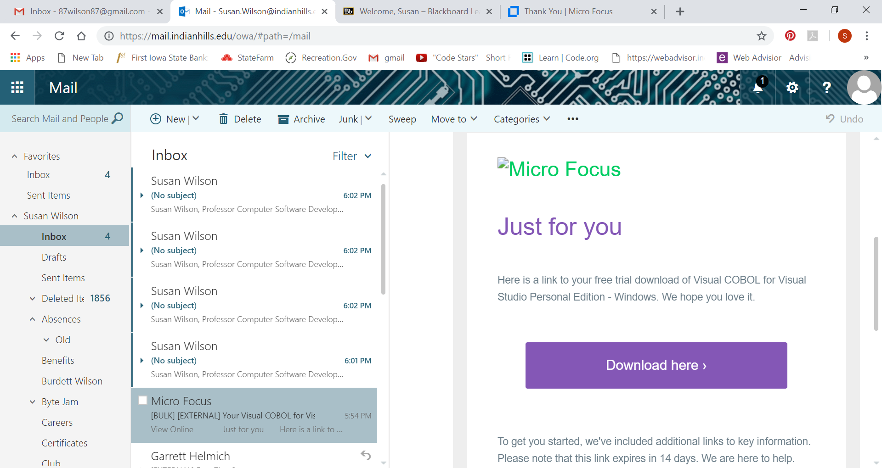

* 1. Download the software from the email link.
  2. Click on Visual Cobol for Visual Studio Personal Edition
  3. Click on download
  4. Agree to the terms and run the .exe
  5. You will need to restart your computer
  6. This will give you a full 1 year installation

1. Create a folder on your C: drive called Cobol